What is Bias?
To make predictions, our model will analyze our data and find patterns in it. Using these patterns, we can make generalizations about certain instances in our data. Our model after training learns these patterns and applies them to the test set to predict them.
Bias is the difference between our actual and predicted values. Bias is the simple assumptions that our model makes about our data to be able to predict new data.
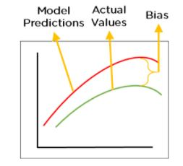
Figure 2: Bias
When the Bias is high, assumptions made by our model are too basic, the model can’t capture the important features of our data. This means that our model hasn’t captured patterns in the training data and hence cannot perform well on the testing data too. If this is the case, our model cannot perform on new data and cannot be sent into production.
This instance, where the model cannot find patterns in our training set and hence fails for both seen and unseen data, is called Underfitting.
The below figure shows an example of Underfitting. As we can see, the model has found no patterns in our data and the line of best fit is a straight line that does not pass through any of the data points. The model has failed to train properly on the data given and cannot predict new data either.
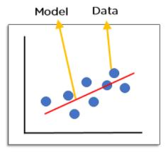
Figure 3: Underfitting

What is Variance?
Variance is the very opposite of Bias. During training, it allows our model to ‘see’ the data a certain number of times to find patterns in it. If it does not work on the data for long enough, it will not find patterns and bias occurs. On the other hand, if our model is allowed to view the data too many times, it will learn very well for only that data. It will capture most patterns in the data, but it will also learn from the unnecessary data present, or from the noise.
We can define variance as the model’s sensitivity to fluctuations in the data. Our model may learn from noise. This will cause our model to consider trivial features as important.
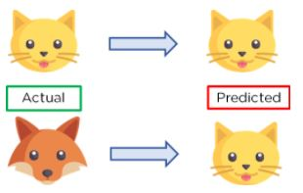
Figure 4: Example of Variance
In the above figure, we can see that our model has learned extremely well for our training data, which has taught it to identify cats. But when given new data, such as the picture of a fox, our model predicts it as a cat, as that is what it has learned. This happens when the Variance is high, our model will capture all the features of the data given to it, including the noise, will tune itself to the data, and predict it very well but when given new data, it cannot predict on it as it is too specific to training data.
Hence, our model will perform really well on testing data and get high accuracy but will fail to perform on new, unseen data. New data may not have the exact same features and the model won’t be able to predict it very well. This is called Overfitting.
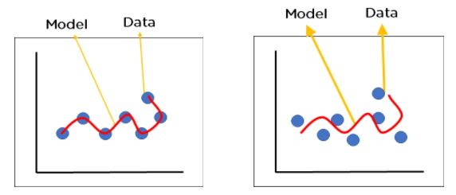

Bias-Variance Tradeoff
For any model, we have to find the perfect balance between Bias and Variance. This just ensures that we capture the essential patterns in our model while ignoring the noise present it in. This is called Bias-Variance Tradeoff. It helps optimize the error in our model and keeps it as low as possible.
An optimized model will be sensitive to the patterns in our data, but at the same time will be able to generalize to new data. In this, both the bias and variance should be low so as to prevent overfitting and underfitting.
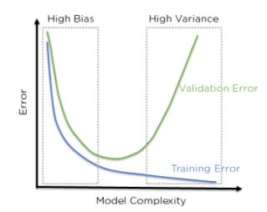
In the above figure, we can see that when bias is high, the error in both testing and training set is also high.If we have a high variance, the model performs well on the testing set, we can see that the error is low, but gives high error on the training set. We can see that there is a region in the middle, where the error in both training and testing set is low and the bias and variance is in perfect balance.
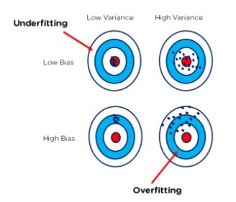
The above bull’s eye graph helps explain bias and variance tradeoff better. The best fit is when the data is concentrated in the center, ie: at the bull’s eye. We can see that as we get farther and farther away from the center, the error increases in our model. The best model is one where bias and variance are both low.

